Off the Edge Dragon Boat Team is buying a
BIG Dragon Boat! Wanna help out?
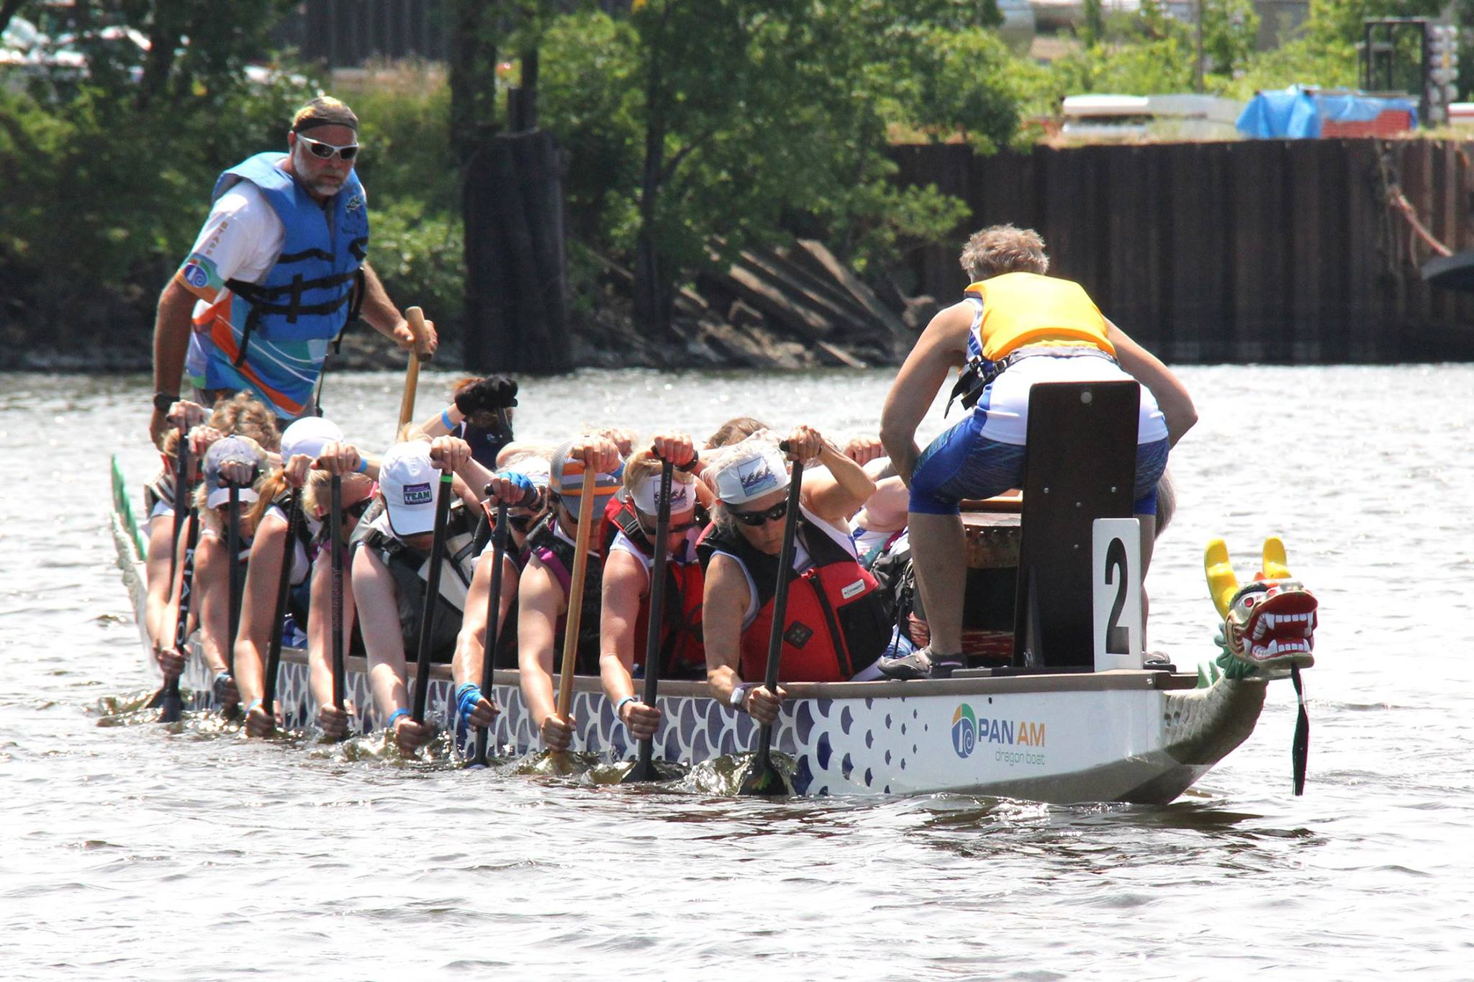
Take this form to Costa Farm & Greenhouse 9411 Dellwood Rd (Hwy 96 between Jamaca and Manning Aves)
or farmer’s market
*****Valid Between these dates only: *****
May 5-11, 2018
Present to Cashier at checkout. Costas will donate 15% of your (pre-tax) purchase to our team!! Your sincere thanks to you for supporting our fundraiser!!
Hours @ COSTA’S: 9am—6:30pm seven days a week.
NO ADDITIONAL DISCOUNTS OR COUPONS MAY BE USED IN CONJUNCTION
Check out all our plant varieties at our new website costafarm.com Cashier Please Note Purchase AMOUNT______________________________
EMAIL____________________________NAME_______________

